

**DFW course on Wheat Genetics**

**John Innes Centre, Norwich, UK**

**19-23 November 2018**

The BBSRC funded **Designing Future Wheat** ([**DFW**](http://www.wheatisp.org/)) Institute Strategic Programme spans eight UK research institutes and universities and aims to develop new wheat germplasm containing the next generation of key traits. The aim of this DFW course is to offer training in important methodologies employed by different groups within DFW. The participants will gain the skills necessary to apply these methodologies in their own research.

# TARGET AUDIENCE

The course is aimed at anyone with an interest in cereals research and crop breeding. The course is an entry level introduction, giving a taste of crop development and phenotyping, wheat genetics and genomics, wheat pathology, sources of genetic diversity in wheat and genomics data resources. Applications are welcome from UK and international undergraduates, breeders, PhD students, and postdocs. A total of **16 places** are available for this course.

The course is a five-day-programme of classroom lectures and hands-on exercises. A guest speaker representing UK commercial breeding and a visit to a commercial breeding programme will expand the topics covered. There will also be opportunities for the whole group to enjoy social activities and discussions.

# PREREQUISITES

It is essential that participants are fluent English speakers, as this intensive course will be given in English. Successful applicants will be provided with bibliography to read in advance.

# PROGRAM COSTS

The registration fee is **£395**, payable in advance. This includes:

* Accommodation including breakfast for four nights: Monday 19 November to Friday 23 November. The accommodation is situated on the Campus of the University of East Anglia (UEA), Norwich.
* Lunches and refreshments Monday to Friday and the workshop dinner on Thursday evening.
* Transport for the visit to the breeding station.

**Please note - participants are responsible for booking and paying for their own travel arrangements to and from Norwich, i.e. visas, flights, train, coach or taxi travel.**

Successful applicants will be notified shortly after the application deadline and will be sent an invoice for their registration fee to be paid by bank transfer within two weeks.

JIC will help with practicalities of visa arrangements, e.g. send invitation letters, as necessary.

# APPLICATION DEADLINE

The deadline for submission of application is **Friday 29 June 2018.**

Applicants are required to submit their completed application form, CV (maximum length two sides of A4) and a letter of recommendation from their Head of Department (or equivalent).

Applications should be sent by email to [dfw.course@jic.ac.uk](mailto:dfw.course@jic.ac.uk) quoting “**DFW course 2018**”.

Preliminary Programme 2018

Day 1 Monday 19 November

* Introduction of tutors and students
* Wheat Inflorescence Development (Speaker from John Innes Centre)
  + Introduction to wheat inflorescence development, from the vegetative to reproductive transition
  + Practical on wheat development that will include the dissection of a wheat inflorescence
* The use of Molecular Markers in Wheat Breeding (Speaker from Bristol University)
  + What are molecular markers
  + What do molecular markers tell us about wheat genetic diversity
  + How are molecular markers being used to improve the efficiency of wheat breeding
  + What does the future hold for molecular markers

Day 2 Tuesday 20 November

* Wheat Genomic Resources (Speaker from John Innes Centre)
  + Functional Genetic resources
  + Expression databases
  + Co-expression networks
  + Pan-genome
* Talk: Recombination in wheat (Speaker from John Innes Centre)
* Phenotyping and Wheat Physiology (Speakers from Rothamsted Research & Earlham Institute)
  + 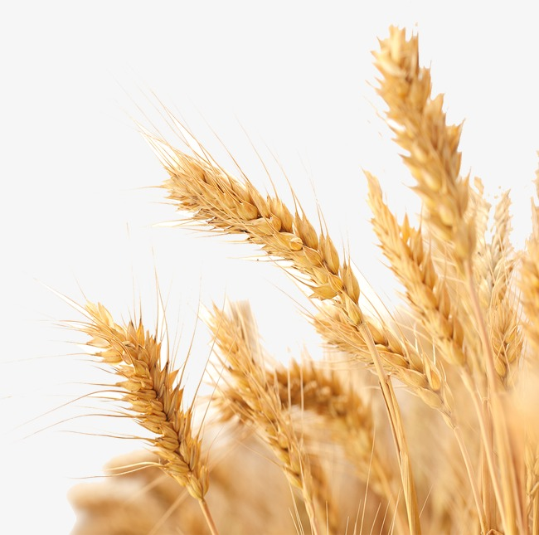Introduction to field phenotyping using imaging technologies
  + Image analysis workshop
  + Low-cost wheat phenotyping solutions
  + Unmanned Aerial Vehicles as a platform for phenotypic data collection

Day 3 Wednesday 21 November

* From QTL to Breeding Pipeline (Speakers from John Innes Centre)
  + Genetic mapping
  + QTL mapping
  + Marker assisted selection and NIL validation
  + Breeders’ Toolkit
* Trip to a wheat breeding station (Limagrain)

Day 4 Thursday 22 November

* Talk: Starch traits for healthier wheat (Speaker from Quadram Institute)
* Talk: Grain Structure, Composition and Quality (Speaker from Rothamsted Research)
* Wheat Synthetics & tetraploid x hexaploid wheat (Speakers from NIAB)
  + Material creation and use
  + How to make synthetic wheat: hands-on practical activities
* Tour of JIC Field Station
* Diversity from Wild Relatives (Speakers from Nottingham University)
  + The wild relatives of wheat and their use in introgression.
  + Crossing the wild relatives with wheat.
  + The joys of threshing.
  + Detection and characterisation of introgressions.

*Workshop dinner*

Day 5 Friday 22 November

* Talk: Wheat Pathology (Speaker from John Innes Centre)
* Guest speaker: Chris Burt (RAGT)
* Visit of Germplasm Research Unit at JIC
* Data-driven Wheat Research (Speakers from the Earlham Institute & the European Bioinformatics Institute)
  + EI Grassroots data resources - the DFW "portal"
  + EBI Ensembl Plants resource

Speakers include: Amanda Burridge (Bristol U), Andrew Riche, Pouria Sedeghi-Tehran, Nicholas Virlet, Malcolm Hawkesford and Peter Shewry (R Res), Daniel Reynolds, Rob Davey (EI), Fiona Leigh, Richard Horsnell and Alison Bentley (NIAB), Brittany Hazard (QI), Julie and Ian King (Nottingham U). Dan Bolser and Guy Naamati (EBI), Azahara Martin-Ramirez, Simon Orford, Noam Chayut, Cathy Mumford, Sarah Collier, Michelle Leverington-Waite, Luzie Wingen, Cristobal Uauy, Scott Boden, Paul Nicholson and Simon Griffiths (JIC).

This announcement and further details on the course, including feedback from previous courses, can be found at this link: [http://WISPlandracepillar.jic.ac.uk/training.htm](http://wisplandracepillar.jic.ac.uk/training.htm)

************